I. Introduction and Literature Review
Introduction
This project addresses the challenge of selecting effective fitness routines by integrating Model-Based Collaborative Filtering with Time Series Forecasting. We employed a Matrix Factorization approach—treating workout programs as "users"—to uncover latent stylistic patterns for personalized recommendations beyond simple keyword matching. Based on this, a time series model[blah blah blah blah]. This dual-method framework empowers users to not only discover stylistically relevant programs but also anticipate their potential performance outcomes.

Collaborative filtering for workout recommendation
Collaborative filtering is a decent fit for our recommendation system because users repeatedly perform exercise and leaving an exercise history that the system can learn from. When logging workout history, feedback is usually implicit as such ‘performed’, ‘skipped’, or ‘repeated’, rather than a specific number-based ratings, so ranking metrics like Precision@k or NDCG@k are more appropriate in this case. Surveys of sports recommender systems report that classic CF (user–user, item–item) and matrix factorization are common and effective, especially when combined with simple domain signals such as equipment and goals. These systems also emphasizes on context to boost performance, which is related to the user input part of our project. (Felfernig et al. 2024).
Adding body-part focus and explanations
Users often ask for workouts that target specific muscle groups. A recent paper mentioned and proposed knowledge-graph–enhanced exercise recommendation (KG4EER) that links exercises to muscles and goals to guide recommendations and provide human-readable explanations (for example, “recommended because it trains the posterior chain”). Even if we implement only classic CF for the course, we can adopt the idea: tag each exercise with its muscle groups, pre-filter to the requested body parts, and re-rank by CF score multiplied by muscle coverage. This improves relevance and lets us show rationales in the UI (Guan et al. 2025).
Time Series Modeling for Weight Projections
With obesity rates on the rise, Elina Helander et. al. aimed to answer how tim series modeling can be applied to the long term self-monitoring of body weight. Using autoregressive models, could meaningful insights show us patterns in behavior and insights into weight loss over time. From 2 participants tracked from 2005 to 2008 using self reported recorded daily weights. Cyclical fluctuations were found both on weekly and monthly scales. Weight was reflective of seasons, which can be explained by vacations and increased sociability in summer compared to more isolated winters. On a weekly basis, weight from weekend behaviors seemed to be reflected early on in the week, with it typically dissipating by the end of the next week (Elina Helander et. al. 2015). These patterns will be personal for each individual and not reflective of a population, but these findings to demonstrate the strong presence of daily weight fluctuations based on personal patterns.
Our Adaptations
Based on research from Elina Helander et. al. daily weights are inconsistent, with fluctuation that happens based on factors like diet, hydration, and bodily functions. Weight changes over time and actual progress may be hard to track. The goal of the study by Elina Elander et. al. was to reveal the prevalence of these factors and demonstrate cyclical patterns and trends in weight fluctuation (Elina Helander et. al. 2015). Our project looks to instead use similar time series methods to do the opposite and show users long term progress, with glimpses into the future to more accurately help people meet fitness goals. Mirroring their methodology, we can change the target to instead show users their current projections to provide more realistic timelines for weight loss and allow users to act proactively to adjust their routine accordingly. By factoring in calories burned each day, an added detail can improve model performance and create our desired outcome of a model reflecting a users trajectory over N months, or any timeline that fits user goals.
References
Felfernig, Alexander, Selma Polat-Erdeniz, Clemens Uran, et al. 2024. “Sports Recommender Systems: Overview and Research Directions.” Journal of Intelligent Information Systems 62: 1125–1164. https://doi.org/10.1007/s10844-024-00857-w
Guan, Qifan, Junjie Chen, Xian Ren, and Chao Zhang. 2025. “Explainable Exercise Recommendation with Knowledge Graph.” Neural Networks. https://doi.org/10.1016/j.neunet.2024.106954
Helander, E., Pavel, M., Jimison, H., & Korhonen, I. (2015). Time-series modeling of long-term weight self-monitoring data. 2015 37th Annual International Conference of the IEEE Engineering in Medicine and Biology Society (EMBC), 1616–1620. https://doi.org/10.1109/embc.2015.7318684

II. ML Methodology and Data Collection
Collaborative filtering
Data Sources: We utilized two Kaggle datasets: `gym-exercise-data` (containing metadata for individual exercises like body part, equipment, and rating) and `fitness-and-workout-dataset` (containing workout program and its metadata like description, time, and experience level).
How data were curated: Since there was no pre-existing link between the workout programs and the exercises, we developed a rule-based mapping algorithm in `data_preprocessing.ipynb` to synthesize these interactions:
1. Body Part Inference: We implemented a regex-based keyword extraction to infer target body parts (for example, ‘bench press’ will be mapped with ‘chest’ since the major muscle trained from bench press is chest) from the unstructured text titles and descriptions of the workout programs.
2. Compatibility Mapping: We created a dense interaction matrix by linking programs to exercises based on three compatibility criteria:
- Body Part Match: The exercise targets the same body part inferred for the program.
- Level Compatibility: The exercise difficulty (Beginner/Intermediate/Expert) aligns with the program's intended experience level.
- Equipment Compatibility: The exercise requires equipment available in the program's setting (for example ‘At Home’ will be mapped with ‘'Body Only', 'Bands', 'None', 'Exercise Ball', 'Foam Roll', 'Dumbbell', since we assume that these equipments are accessible at home)
3. Filtering: We removed mappings where exercises lacked a quality rating, also removed mappings where programs is not mapped with any specific body parts, resulting in a final `program_exercise.csv` dataset that serves as the ground data for our model, which contains the following features: ['program_id', 'program_title', 'program_description', 'program_goal', 'program_level', 'program_time_minutes', 'program_equipment','program_bodyparts', 'exercise_id', 'exercise_title', 'exercise_bodypart', 'exercise_equipment', 'exercise_level', 'exercise_rating']
Time Series
Data Sources:

How data were curated:

ML Methods Overview
ML Method 1: Model-Based Collaborative Filtering (Matrix Factorization)
We implemented a custom Matrix Factorization system. While standard Collaborative Filtering (CF) typically uses a User-Item matrix, our approach adapts this structure by treating Programs as "Users" and Exercises as "Items".
Mathematical Formula: We constructed an interaction matrix R of size N(programs) x M(exercises). We decomposed this matrix into two lower-rank latent factor matrices, P (Program Factors, size N x K) and Q (Exercise Factors, size M x K), such that R is approximately equal to P x Q^T.
Optimization: We used Gradient Descent with L2 regularization to minimize the reconstruction error. This allows the model to learn K=15 latent features (For example, equipment constraint and experience level constraint factor) that explain why certain exercises appear in certain programs.
Scoring: Recommendations are generated by projecting a user's "Liked Exercises" vector u against the reconstructed matrix R^hat = P x Q^T. The score for program p is calculated as the dot product of the reconstructed program vector and the user vector. This effectively recommends programs that are conceptually similar to the user's preferences, even if they do not contain the exact same exercises. Additionally, we apply a strict penalty to programs containing exercises explicitly 'Disliked' by the user. This effectively recommends programs that are conceptually similar to the user's preferences, even if they do not contain the exact same exercises.

ML Method 2: [Time Series Model here]

III. ML Results and Interpretation
Results – Collaborative filtering
Matrix Factorization model successfully learned latent structures within the workout data.
Convergence: The manual Gradient Descent implementation converged stably with a learning rate of alpha=0.0001 over 200 iterations.
Qualitative Performance: The model demonstrated the ability to generalize beyond exact keyword matching. For example, when a user selected "Bench Press" (a Chest/Strength exercise), the model recommended programs like "1 PowerLift Per Day" and "12 Week Transformation". Crucially, these programs were highly relevant even if they contained variations of the exercise (e.g., "Dumbbell Press") rather than the exact input, proving that the latent factors (P and Q) successfully captured the underlying concept of "Upper Body Strength" rather than just memorizing exercise names.
Sparsity Handling: The reconstruction step successfully filled in the sparse interaction matrix. Programs that originally had 0 ratings for specific exercises were assigned non-zero predicted scores, allowing the system to recommend "hidden gems"—programs that are stylistically perfect for the user but might have been missed by a simple content filter.
Image sample of the UI with specified input:
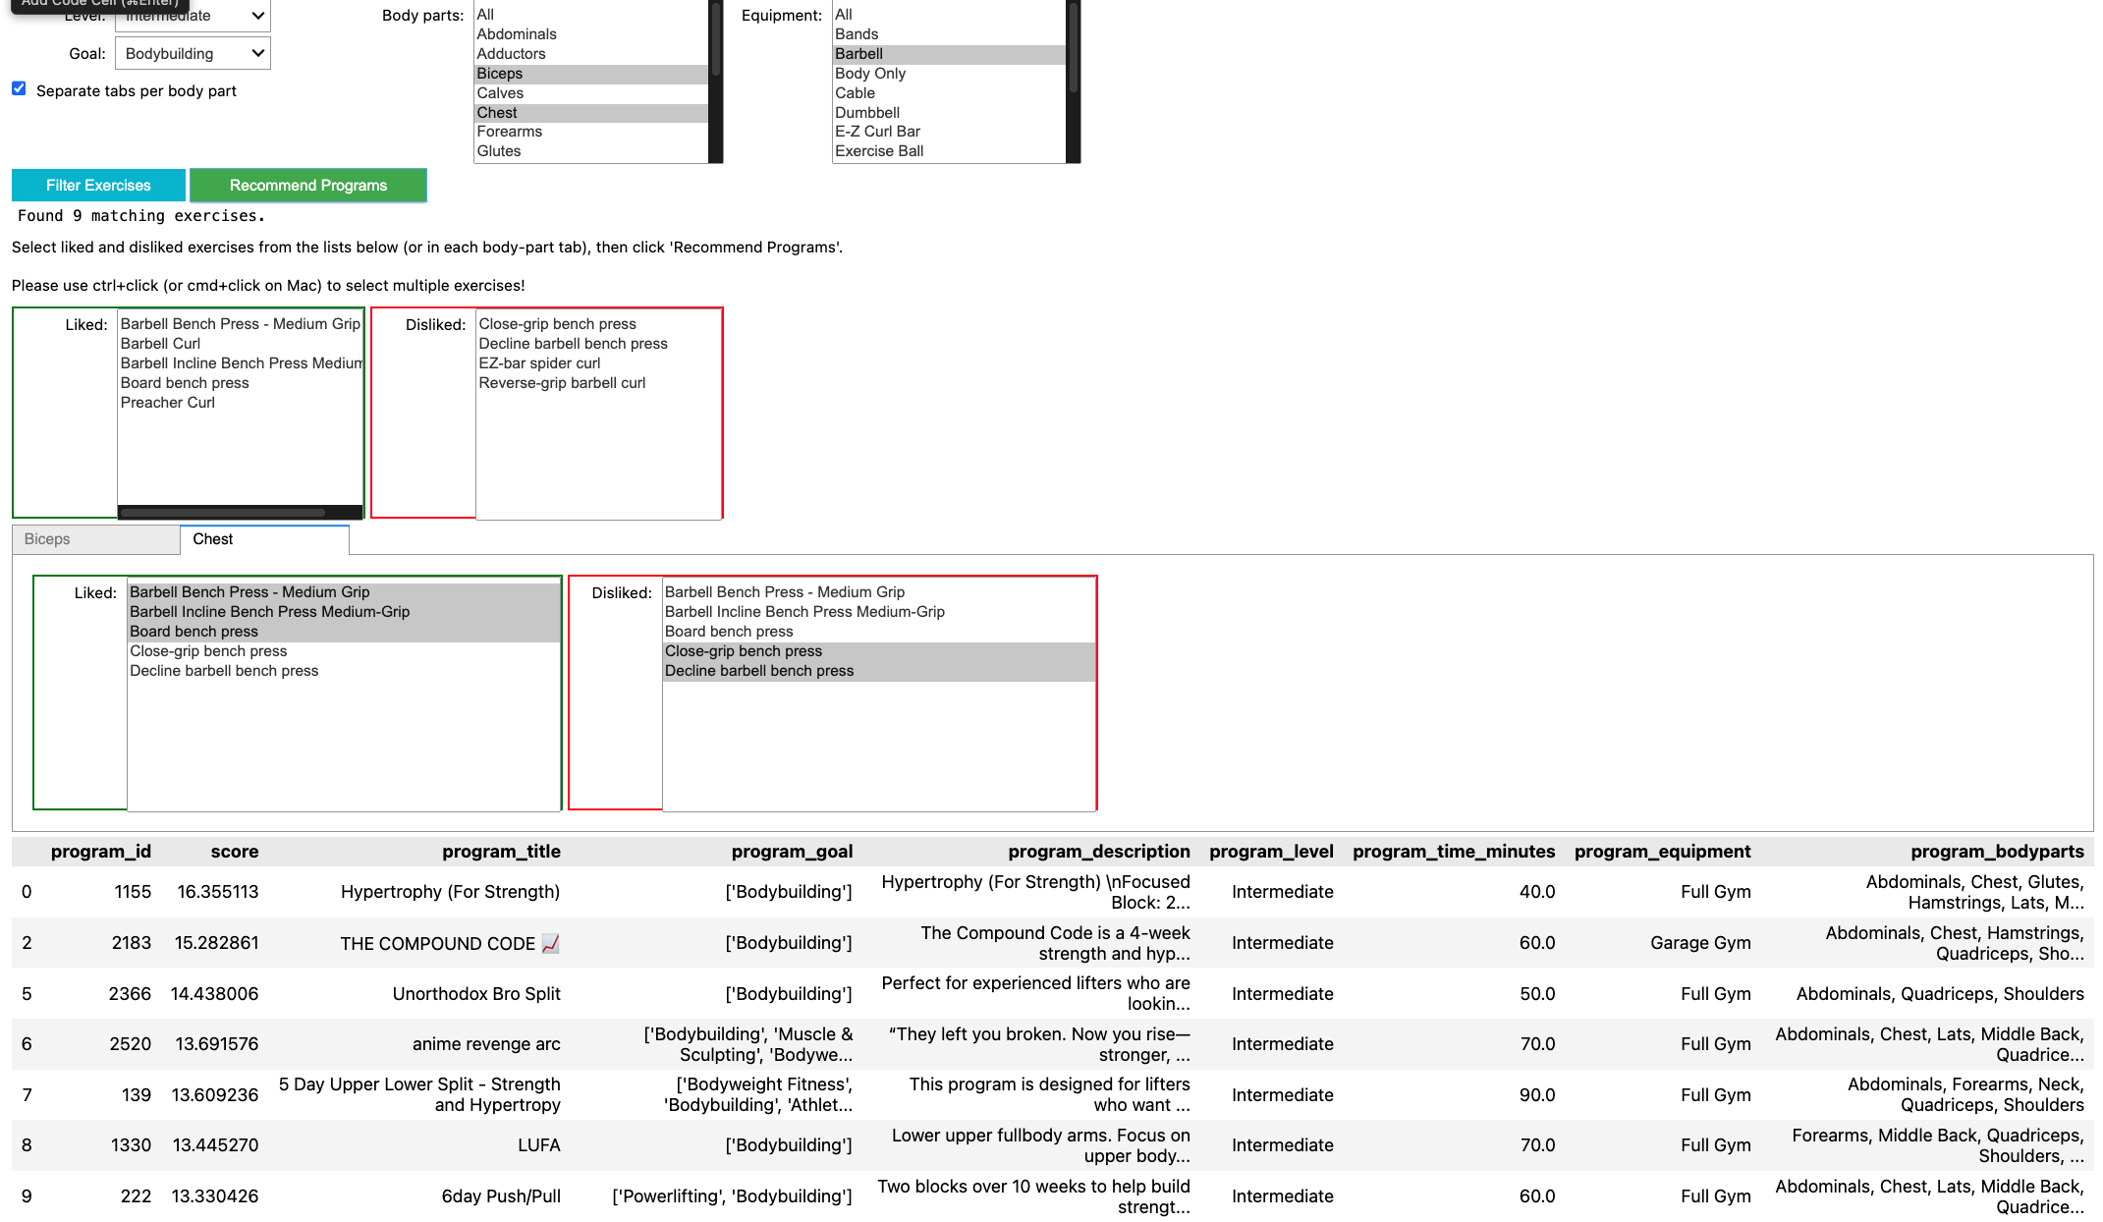

Results – Time Series Prediction

IV. Conclusions and Future Work
Summary of Findings
Callaborative filtering: Our study demonstrates that Matrix Factorization can be an effective technique for workout program recommendation, even in the absence of user interaction history. By inverting the standard Collaborative Filtering(treating Programs as Users), we extracted latent stylistic features from workout data. The model moved beyond rigid filtering to provide recommendations that capture the intent of a user's workout preferences.
Time Series prediction:

Assumptions and Appropriateness
Collaborative filtering
Assumption: The core assumption of Matrix Factorization is that "users" (programs) who agree on some items (exercises) will agree on others. This held true; programs targeting "Legs" consistently contained clusters of related leg exercises, validating the use of latent factors.
Data Appropriateness: The use of intrinsic exercise ratings as a proxy for "user ratings" was a necessary heuristic. While appropriate for a cold-start system, it assumes that a high-quality exercise is equally valuable in all compatible programs, which may not always be true (e.g., a high-rated cardio move might be "noise" in a powerlifting program).
Times Series
Assumption:
Data Appropriateness:

Drawbacks and Future Work
Collaborative filtering
Cold Start Problem: Our current model requires a user to know exactly which exercises they like. A true "User-User" system would allow recommendations based on demographic similarity (e.g., "Other 25-year-old males liked this") (If we have user data available)
Future work: Currently, the system operates in a "stateless" manner. It treats Programs as users and Exercises as items. This means it understands the structure of a workout perfectly, but it knows nothing about the preferences of actual human beings. It relies entirely on the user manually selecting exercises they like in the current session. If user interaction data becomes available (e.g., logs of users completing specific programs), the system should implement a secondary Matrix Factorization layer based on a User × Program interaction matrix. This would enable Social Collaborative Filtering: that suggests programs to users based on other similar users with similar preferences and history.
Time Series

V. Appendix: Implementation
Collaborative filtering
# --- Matrix Factorization (Collaborative Filtering) ---
def train_matrix_factorization_manual(R_matrix, K=15, steps=200, alpha=0.0002, beta=0.02):
"""
Decomposes R into P and Q such that R approx P @ Q.T
using Gradient Descent with L2 regularization (Numpy implementation).

R_matrix: (n_programs, n_exercises)
K: Number of latent factors
"""
n_p, n_e = R_matrix.shape
np.random.seed(42)

# Scale R to 0-1 range for stability during training
max_val = R_matrix.max()
if max_val > 0:
R_norm = R_matrix / max_val
else:
R_norm = R_matrix

# Initialize latent factors with small random values
P = np.random.normal(scale=1./K, size=(n_p, K))
Q = np.random.normal(scale=1./K, size=(n_e, K))

# Gradient Descent Loop
for step in range(steps):
# Prediction
R_pred = P @ Q.T

# Error
E = R_norm - R_pred

# Gradients (Vectorized)
# dLoss/dP = -2 * E @ Q + 2 * beta * P
# dLoss/dQ = -2 * E.T @ P + 2 * beta * Q
grad_P = -2 * (E @ Q) + 2 * beta * P
grad_Q = -2 * (E.T @ P) + 2 * beta * Q

# Update weights
P -= alpha * grad_P
Q -= alpha * grad_Q

if step % 20 == 0:
loss = np.sum(E**2)
# print(f"Step {step}/{steps} - Loss: {loss:.4f}")

# Rescale P back up so R_hat is in original range (approx)
# We can just multiply P by max_val to restore scale
P = P * max_val

return P, Q

print("Training Manual Matrix Factorization Model...")
# Train on the existing R matrix
P_factors, Q_factors = train_matrix_factorization_manual(R, K=15, steps=200, alpha=0.0001)
# Reconstruct the matrix (denoised/filled)
R_hat = P_factors @ Q_factors.T
print("Training Complete. R_hat shape:", R_hat.shape)
if np.isnan(R_hat).any():
print("WARNING: R_hat contains NaNs! Try reducing alpha.")

